HSI

for

Digital Elevator

Version 1.5 Proposed

Prepared by /   
- Ahmed Refaat  
- Marcelle Samir

|  |  |  |  |  |
| --- | --- | --- | --- | --- |
| **Document name** | **Version** | **Author** | **Last update Date** | **Document Status** |
| HSI_DIGITAL_ELEVATOR | V_1.5 | Ahmed Refaat | Feb 8, 2020 | Proposed |

Status table

Revision History

|  |  |  |  |  |  |
| --- | --- | --- | --- | --- | --- |
| **Name** | **Version** | **Author** | **Date** | **Change Description** | **Doc. Status** |
| HSI_DIGITAL_ELEVATOR | V_1.0 | Ahmed Refaat,  Marcelle Samir | Jan 23, 2020 | Initial creation of the HSI Document. | Draft |
| HSI_DIGITAL_ELEVATOR | V_1.1 | Ahmed Refaat,  Marcelle Samir | Jan 28, 2020 | Applying review’s suggested modifications | Proposed |
| HSI_DIGITAL_ELEVATOR | V_1.2 | Ahmed Refaat | Feb 5, 2020 | - Reformatted the requirements  - Added pin description table | Draft |
| HSI_DIGITAL_ELEVATOR | V_1.3 | Marcelle Samir | Feb 5, 2020 | - Requirements modification according to reviewing the CRS document  * adding motor into the requirements  * reviewing each requirement details to make sure it covers all CRS points  - modifying the document formatting  - editing pin description table design  - Editing the components block diagram | Proposed |
| HSI_DIGITAL_ELEVATOR | V_1.4 | Marcelle Samir | Feb 7, 2020 | - unifying the requirement ID Naming  - adding more details to “Change Description” section  -changing the diagram | Proposed |
| HSI_DIGITAL_ELEVATOR | V_1.5 | Ahmed Refaat | Feb 8, 2020 | - Adjusting the location of the revision history table  - Adjusting the location of the status of the document  - Adding pin table as a requirement (Req_DIGELV_HSI_01_V1.1)  - Modifying requirement 04  - Adding reference table | Proposed |

Table of Contents

Status table 2

Revision History 3

01. Introduction 5

Purpose 5

2. Components block diagram 6

3. list of components 6

4. Hardware/Software specification 7

Req_DIGELV_HSI_01_V1.1 7

Req_DIGELV_HSI_02_V1.2 8

Req_DIGELV_HSI_03_V1.4 8

Req_DIGELV_HSI_04_V1.3 9

Req_DIGELV_ HSI_05_V1.2 9

5. The Reference Document table 10

# 01. Introduction

## Purpose

This document describes the hardware-software interface specifications for the digital elevator project as HSI document.

# 2. Components block diagram

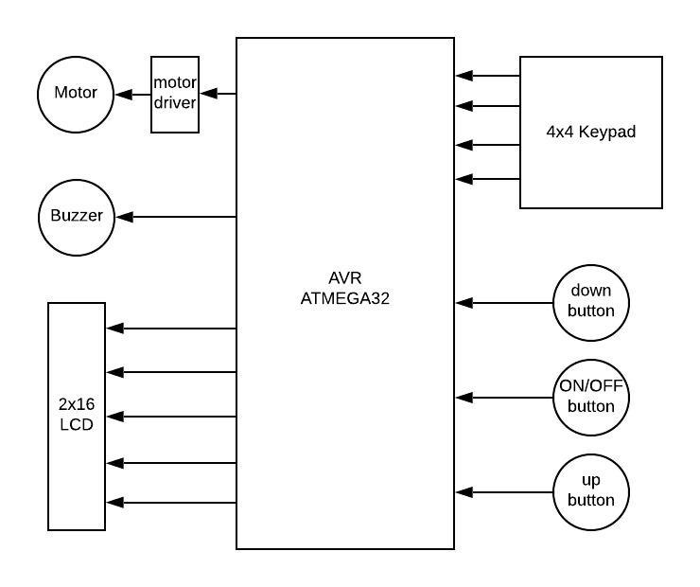

# 3. list of components

|  |  |  |  |  |
| --- | --- | --- | --- | --- |
|  | Component’s name | Quantity | Type | Notes |
| 1 | AVR kit | 1 | controller | ATmega32A controller |
| 2 | LCD | 1 | OUTPUT device | Size of (2x16) |
| 3 | Keypad | 1 | INPUT device | Size of (4x4) |
| 4 | Buzzer | 1 | OUTPUT device |  |
| 5 | Push button | 3 | INPUT device | 2 for up/down, 1 for ON/OFF |
| 6 | Motor driver | 1 | OUTPUT device | LM298 |
| 7 | Motor | 1 | OUTPUT device | 5v DC motor |

4. Hardware/Software specification

****Req_DIGELV_HSI_01_V1.1****

|  |  |  |  |
| --- | --- | --- | --- |
| Pin num. | Symbol | Direction | Connection |
| 1 | PB0 | Output | LCD_D0 |
| 2 | PB1 | Output | LCD_D1 |
| 3 | PB2 | Output | LCD_D2 |
| 4 | PB3 | Output | LCD_D3 |
| 5 | PB4 | Output | LCD_D4  fffffdddddddd |
| 6 | PB5 | Output | LCD_D5 |
| 7 | PB6 | Output | LCD_D6 |
| 8 | PB7 | Output | LCD_D7 |
| 14 | PD0 | Output | LCD_RS |
| 15 | PD1 | Output | LCD_RW |
| 16 | PD2 | Output | LCD_Enable |
| 17 | PD3 | Output | Keypad_R1 |
| 18 | PD4 | Output | Keypad _R2 |
| 19 | PD5 | Output | Keypad _R3 |
| 20 | PD6 | Output | Keypad _R4 |
| 21 | PD7 | Input | Keypad _C1 |
| 22 | PC0 | Input | Keypad _C2  C |
| 23 | PC1 | Input | Keypad _C3 |
| 24 | PC2 | Input | Keypad _C4 |
| 25 | PC3 | Output | Buzzer |
| 26 | PC4 | Input | Button1 |
| 27 | PC5 | Input | Button2 |
| 28 | PC6 | Input | Button3 |
| 29 | PC7 | Output | Motor_driver_IN1 |
| 33 | PA7 | Output | Motor_driver_IN2 |
| 34 | PA6 | Input | Not connected |
| 35 | PA5 | Input | Not connected |
| 36 | PA4 | Input | Not connected |
| 37 | PA3 | Input | Not connected |
| 38 | PA2 | Input | Not connected |
| 39 | PA1 | Input | Not connected |
| 40 | PA0 | Input | Not connected |

|  |  |
| --- | --- |
| Requirement ID | ****Req_DIGELV_HSI_02_V1.2**** |
| Title | **Enter user’s data.** |
| Description | **Hardware needed:**  **- keypad**  **It’s used as input device to enter user’s name and password.**  **- LCD (2*16)**  **It’s used as output device to display the user’s entered information**  **- Micro controller**  **The main component to write the software on** |

|  |  |
| --- | --- |
| Requirement ID | ****Req_DIGELV_HSI_03_V1.4**** |
| Title | **Verifying user’s ID and selecting the direction** |
| Description | **Display ok if the ID is correct, up and down buttons are used to change the floor desired by the user.**  **Hardware needed:**  **- LCD**  **To display the status**  **- 2 push buttons (Up and Down)**  **It’s used as INPUT device to identify the  desired direction**   * **Motor (&motor driver)**   **To show the buttons response** |

|  |  |
| --- | --- |
| Requirement ID | ****Req_DIGELV_HSI_04_V1.3**** |
| Title | **Maximum number of trials** |
| Description | **In case of Exceeding the number of the defined number of trials (3).**  **Hardware needed:**  **- LCD**  **it will display NOK**  **- Buzzer**  **The buzzer will start beeping.** |

|  |  |
| --- | --- |
| Requirement ID | ****Req_DIGELV_ HSI_05_V1.2**** |
| Title | **Reset functionality.** |
| Description | **Hardware needed:**  **Reset push button (on/off button)**  **A reset for the whole system is done when pressing on /off button for 2 sec** |

|  |  |  |  |
| --- | --- | --- | --- |
| Ref number | Document | version | status |
| 1 | CRS | V1.0 | Proposed |
| 2 | SIQ | _ | _ |

5. The Reference Document table